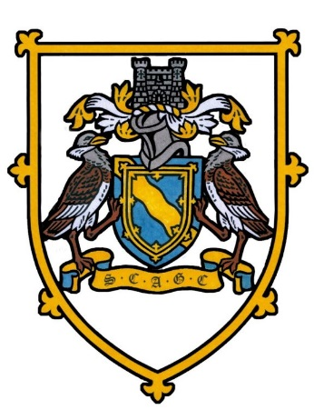
SOCIETY OF CAMBRIDGESHIRE AREA GOLF CAPTAINS
Nicholls Salver
Meridian Golf Club
Wednesday 6th May 2026
18 HOLE INDIVIDUAL STABLEFORD. 95% HANDICAP. YELLOW TEES
THERE WILL BE NEAREST TO THE PIN PRIZES IN AID OF THE CAPTAINS CHARITY
.
12.04pm | Alan Woods 1st 38 points  Brampton Park (Captain) | Roger Tacq  Ramsey | David Creek  Brampton Park | Paul Ryman  Barkway Park
12.12pm | Hugh Carlisle (Hon Sec)  Girton NP on the 3rd | Peter Luetchford  Barkway Park | Chris Flack  St Neots | Frank Dobbs  Cambridgeshire
See. 12.20 pm | John Williams (V/Captain)  Gog Magog | Trevor Dean 3rd 34 points  Girton | Doug Poole  Brampton Park | Phil Black NP on the 17th  Heydon Grange
12.28 pm | Steve Whitney  St Neots | Chris Atkin (B)  Girton | Ray Smith  Barkway Park | John Tellett  Brampton Park
12.36 pm | Geoff Link  Gog Magog | Steve Kane  Knebworth | Mike Wallis  Brampton Park | Lyn Griffith  Ramsey
12.44 pm | John Harris (B)  Ramsey | David Francis (Treasurer) (B)  Barkway Park | Simon Bottomley  Brampton Park | Ian Lennon 2nd 36 points  Meridian

Full English Breakfast served at 10.45am Nearest the Pins TBA
NO DINNER and presentation will commence after all players are in NO NEED TO CHANGE
E Mail :-secretary.scagc@outlook.com Tel No: - 07884267492

