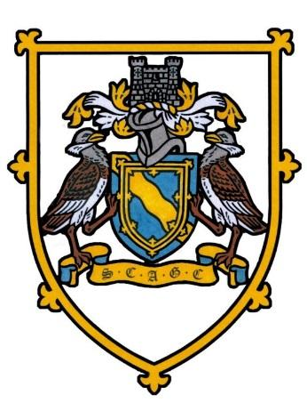
SOCIETY OF CAMBRIDGESHIRE AREA GOLF CAPTAINS
Chas Vincents Captains Day
The Links Newmarket
Friday 27th June 2025
18 HOLE INDIVIDUAL STABLEFORD. 95% HANDICAP. YELLOW TEES
Please bring a prize for the Tombola
Starter is Ian Pountain SCAGC Past Captain 2002
Refreshment will be served on the 11th by
Ian Pountain and Andy Wylie (The Links Club President)
Could members arrive approx. 1 hour before your tee time
.
11.30am | Alan Wood (Vice Captain)  Brampton Park 32 | Roderick Gibbs (President)  Northamptonshire 28 Guest Winner | Gerry McIntyre (President)  Leicestershire Rutland and County 24
11.40am | John Thompson (Immediate Past Captain) 43  St Neots 1st | Steve Finch (President)  Suffolk 26 | Mark Hudson (Captain)  Nottinghamshire 25
11.50am | John Fuller (Past Captain)  Girton G C 30 | Tim Smith (Hon Secretary)  Leicestershire Rutland and County 25 | David Hill (Past President)  Northamptonshire 20
12 Noon | David Creek (Past Captain)  Brampton Park 29 | Graham Denny (Council Member) 36  Suffolk F9 | Stuart Watson (B) 31  Girton G C | Terry Cripps (B) 29  Ramsey
12.10pm | Lyn Griffith 30  Ramsey | Eddie Clark 26  The Links | Steve Whitney 34  St Neots | Doug Poole 32  Brampton Park
12.20pm | Brian Allen 35  The Links | Dave Francis 35  Barkway Park | David Steer 33  Peterborough Milton | Mike Wallis 32  Brampton Park
12.30pm | Peter Nightingale 33  The Links | Steve Kane 36  Knebworth NP2 14th | John Williams 32  Gog Magog | Ray Smith 39  Barkway Park 2nd & Liaison Officers
12.40pm | Stan Hodgson 34  The Links B9 | Hugh Carlisle (Interim Hon Secretary) 29  Girton GC | Craig Young 36  Heydon Grange | Simon Bottomley 36  Brampton Park G C 3rd c/b
12.50pm | Mark Langford 30  Ramsey | Ian Lennon 24  Meriden G C | Greg Davidson 34  Ely City | Paul Ryman 36  Barkway Park
1.00pm | Ray Bolton 33  The Links NP 12th | Merv Pickard 33  St Ives | Glenn Grint (B) 36  Girton G C | Derrick Saunders (B) 33  Girton G C
1.10pm | John Harris (B) 31  Ramsey | Chris Atkin (B) 28  Giron G C | Peter Taylor (B) 31  Saffron Walden | David Littlechild (B) 36  Girton G C
1.20pm | Richard Douglas 33  The Links NP 9th | John Aspinall 29  Ely City NL 18th | Tony Leigh 28  Chesfield Downs | John Tellett 35  Brampton Park
Bacon Rolls served from 10.30am 2 Course Dinner of Chicken Nicoise and dessert of Eaton Mess which will follow completion of Competition and please advise of any dietary requirements.
The Captain requests that Society Shirts/Jumpers for play and Jacket and Society Ties for Dinner to be worn.
Prizes For 1st 2nd and 3rd . Best Front 9 and Best Back 9 and Competition for the Liaison Officers. Nearest to the pins on 9th and 12th and nearest to the pin on 14th with second shot. And a special prize for the nearest to the line on the 18th kindly donated by Mike Wallis.
(B) Buggies
E Mail : hugh.carlisle60@gmail.com Tel No:- 07884267492

