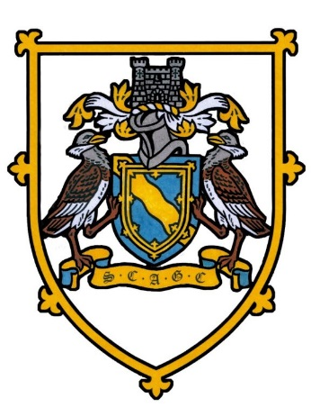
SOCIETY OF CAMBRIDGESHIRE AREA GOLF CAPTAINS
Nicholls Salver
Lakeside Lodge Fen Road, Pidley, PE28 3DF
Wednesday 18th June 2025
18 HOLE INDIVIDUAL STABLEFORD. 95% HANDICAP. YELLOW TEES
THERE WILL BE NEAREST TO THE PIN PRIZES IN AID OF THE CAPTAINS CHARITY
.
12.04pm | Chas Vincent  The Links 37 | Mike Wallis  Brampton Park 31 | Mervyn Pickard  St Ives 26
12.12pm | Hugh Carlisle  Girton 30 | Steve Searle  St Neots 33 | Dave Francis  Barkway Park 33 | John Williams  Gog Magog 28
12.20 pm | Steve Whitney  St Neots 30 | John Fuller  Girton 30 | Ray Smith  Barkway Park 27 | Roger Tacq  Ramsey 28
12.28 pm | Peter Taylor (Buggy)  Saffron Walden 34 | Terry Cripps (Buggy)  Ramsey 34 | Chris Flack  St Neots 33 | Steve Kane  Knebworth 34
12.36 pm | John Tellett  Brampton Park 43 | Paul Ryman  Barkway Park 29 | Lyn Griffith  Ramsey 34 | Greg Davidson  Ely 32
Full English Breakfast served at 10.45am
Nearest the Pins 3rd Steve Whitney 16th Terry Cripps
NO DINNER and presentation will commence after all players are in NO NEED TO CHANGE
E Mail :-hugh.carlisle60@gmail.com Tel No:- 07884267492

