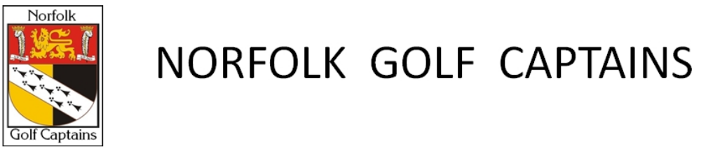

TEAMS FOR ‘THREE COUNTIES 2022’
Versus | CAMBRIDGESHIRE AND BEDFORDSHIRE
At | Thetford GC, Brandon Road, Thetford, Norfolk IP24 3NE
Date | TUESDAY, 14TH JUNE 2022
Assembly time and details | Arrive at 11.45am for bacon roll T/C,  Dinner: Steak & Mushroon pie, creamy mash & seasonal vegetables, Cheesecake with fruit compote. | £45.00 per head | 16 a-side, 1pm start.  Singles Stableford, 95% of CH, Yellow tees, slope 131, 14 scores to count.
MATCH MANAGER: MALCOLM HARDINGHAM, EMAIL:malshe2212@gmail.com TEL: 07957 865117

NORFOLK |  | BEDFORDSHIRE |  |  | CAMBRIDGESHIRE
1  13.00 | PHIL HACKING  (CAPTAIN) | 27 | MARTYN LATCH  (VICE-CAPTAIN) | 39 | STUART WATSON  (VICE-CAPTAIN) | 29
2  13.10 | PETER ALLOTT  (CLUB CAPTAIN) | 37 | CHRIS FOSTER (SECRETARY) | 26 | SIMON BOTTOMLEY | 34
3  13.20 | STEVE MARSH (PRESIDENT) | 34 | MICK VICKERS | 18 | ALAN WOOD (TREASURER) | 26
4  13.30 | MALCOLM HARDINGHAM (MATCH MANAGER) | 23 | DAVID PRICE  (MATCH MANAGER) | 32 | DAVID CREEK  (MATCH MANAGER) | 30
5  13.40 | MARK NIXON | 31 | MARK NEWLAND | 35 | MIKE WALLIS | 25
6  13.50 | RICHARD BALL | 30 | PETER HULANCE | 33 | HUGH CARLISLE | 37
7  14.00 | GORDON CARTWRIGHT | 28 | MIKE SHAW | 26 | JOHN FULLER | 32
8  14.10 | JON CONGDON | 28 | JOHN SIMPSON | 35 | JOHN WILLIAMS | 39
9  14.20 | JOHN STIMPSON | 29 | PAUL BURGESS | 34 | IAN ROBINSON | 34
10  14.30 | ERIC WARNES | 34 | Malcolm Waters | 24 | TONY LEIGH | 32
11  14.40 | JOHN SIMPSON | 35 | NIGEL UNDERWOOD | 25 | GRAHAM HANDSCOMBE | 28
12  14.50 | GARY GOODCHILD | 28 | ROY RODDY | 18 | STEVE BONNETT | 30
13  15.00 | PAUL FILBY (SECRETARY) | 30 | GARRIE BRANDON | 34 | PHIL BLACK | 26
14  15.10 | TREVOR GREEF | 36 | JOHN JONES | 22 | ROGER TACQ | 36
15  15.20 | MARK HOWELL | 26 | KEITH SHIRLEY | 32 | JOHN THOMPSON | 34
16  15.30 | IAN ALDERTON | 30 | Sid Pnienski | 19 | PETER TAYLOR | 29
437 416 450
NOTES: 1. JACKET AND TIE REQUIRED FOR MATCH MEAL
2. BEDFORDSHIRE WON IN 2021

