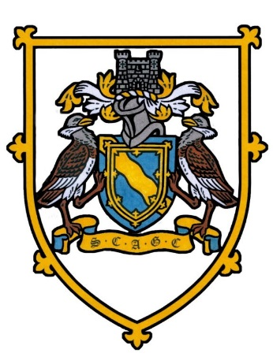
SOCIETY OF CAMBRIDGESHIRE AREA GOLF CAPTAINS
INTER-CLUB ST IVES GC WEDNESDAY MAY 4TH 2022
18 HOLE INDIVIDUAL STABLEFORD. FULL HANDICAP. YELLOW TEES
TEAMS OF 4 PLAYERS WITH THE AGGREGATE OF THE 3 BEST SCORES TO COUNT IN THE EVENT OF A TIE THE FOURTH SCORE WILL BE TAKEN INTO ACCOUNT.
EACH CLUB MAY DECIDE ON TEAM COLOURS, EITHER SCAGC OR THEIR CLUB. THE SCAGC CAPTAIN REQUESTS THAT ALL OF THE TEAM DRESS IN THE SAME CLOTHING
11.20am | MICHAEL SMITH 39 ST IVES GC | JOHN WILLIAMS 32 GOG MAGOG GC | DOUG POOLE 30 BRAMPTON PARK GC | MIKE HOARE 30 ELY CITY GC
11.30am | PETER TAYLOR 31 SAFFRON WALDEN | STEVE SEARLE 38 ST NEOTS GC | ROGER TACQ 32 RAMSEY GC | GRAHAM LOCKE 37 BARKWAY GC
11.40am | GHAS GUEST 33 THE CAMBRIDGESHIRE | KEITH HOWLETT 28 CAMBRIDGE CC | RICHARD DOUGLAS 28 LINKS GC | MALCOLM KNOBEL- FORBES HEYDON GRANGE GC 25
11.50am | STEVE ANDREWS 30 GIRTON GC | KEITH MOORE 36 ST IVES GC | GEOFF LINK 31 GOG MAGOG GC | ALAN WOOD 35 BRAMPTON PARK GC
12.00pm | ALAN TODD 27 ELY CITY GC | ANDREW FISHER 28 SAFFRON WALDEN GC | RICHARD DEAN 35 ST NEOTS GC | JOHN HARRIS 34 RAMSEY GC
12.10pm | RAY SMITH 30 BARKWAY GC | ALAN GOVE 23 THE CAMBRIDGESHIRE | IAN DUKE 32 CAMBRIDGE CC | JOHN TUTTLE 39 LINKS GC
12.20pm | STEVE BONNETT 34 HEYDON GRANGE GC | HUGH CARLISLE 23 GIRTON GC | BRIAN MASON . 33 ST IVES GC | SIMON BOTTOMLEY 30 BRAMPTON PARK GC
12.30pm | MICHAEL PRICE 38 SAFFRON WALDEN GC | GARETH JONES 31 GOG MAGOG GC | MATT VIRGO 24 CAMBRIDGE CC | PETER TALBOT 36 THE CAMBRIDGESHIRE
12.40pm | GRAHAM HANDSCOMBE 30 HEYDON GRANGE GC | MIKE WALLIS 23 BRAMPTON PARK GC | STUART WATSON 34 GIRTON GC | GARY BONNER 33 SAFFRON WALDEN GC
12.50pm | DAVID WOODS 31 ELY CITY GC | ROCK LOVEDAY 37 ST NEOTS GC | TERRY CRIPPS 36 RAMSEY GC | DAVID WALL 32 BARKWAY GC
1.00pm | KEN BREWER 26 CAMBRIDGE CC | BASIL WARREN 28 LINKS GC | CLIVE HAY 36 THE CAMBRIDGESHIRE | IAN SCRIVENER 33 ST IVES GC (CLUB CAPTAIN)
1.10pm | DAVID TOMKINS 27 HEYDON GRANGE GC | ALAN MAWHINNEY 27 RAMSEY GC | GREG DAVIDSON 30 ELY CITY GC | COLIN BROWN 35 GOG MAGOG GC
1.20pm | STUART SPINK 41 GIRTON GC | CHRIS FLACK 38 ST NEOTS GC | DAVID FRANCIS 34 BARKWAY GC | TREVOR CLIFTON 31 LINKS GC
BACON BAPS/COFFEE/TEA FROM 10.30am Nearest the Pin 7th & 12th
CLUB JACKETS & SCAGC TIES
DINNER – 6.00pm ROAST BEEF & YORKSHIRE PUDDING & LEMON TART
Stuart Watson Mobile 07788 564867 stuartwatson48@yahoo.com

